RUNNING TO A STANDSTILL: CARDIAC ARREST IN A HEALTHY MARATHON RUNNER WITH A MYOCARDIAL BRIDGE
A. Cubberley, C. Ngongang, S. Banka
Drexel University College of Medicine/Hahnemann University Hospital, Philadelphia, PA, USA

Background: Sudden Cardiac Death (SCD) after a marathon is a rare event and is usually attributed to hypertrophic cardiomyopathy (HCM), an anomalous coronary artery, or atherosclerotic disease. Myocardial bridging is a congenital anomaly in which a segment of a coronary artery takes a “tunneled” intramuscular course under a “bridge” of overlying myocardium causing coronary compression in systole.
Case Report: A 33-year-old, active male, with no past medical history, collapsed after crossing the finish line at a marathon. He had intensive training leading up to the marathon without prior symptoms. The patient described a sense of heaviness in his legs before collapsing at the finish line. Paramedics responded and initiated cardiopulmonary resuscitation. Initial rhythm analysis was ventricular fibrillation (Figure 1). Patient received 2 shocks and 4 rounds of CPR before return of spontaneous circulation where he fully regained consciousness.
Initial EKG showed normal sinus rhythm with QTc of 438 ms. Vitals and labs including TSH, potassium, urine drug screen, and magnesium were normal. Troponin I was elevated at 0.070 ng/ml, which peaked six hours later at 0.192 ng/ml. Transthoracic echocardiogram showed a normal ejection fraction of 60% with no structural or valvular abnormalities. Cardiac catheterization revealed normal coronary origins, a 20% stenosis of the mid-left anterior descending coronary artery (LAD) and a mid LAD myocardial bridge (Figure 2). Cardiac MRI showed no abnormal enhancement. The patient’s fitness tracker recorded his heart rate being 190-203 bpm throughout the race. The patient was discharged with a life vest. At a follow up appointment the decision was made to ultimately have an ICD implanted.
Discussion: Myocardial bridges can lead to fatal ventricular arrhythmias under conditions of maximal cardiac stress. It is now known, systolic compression of bridges could extend obstruction into diastole at high heart rates, impairing coronary flow causing ischemia. This previously benign condition may have adverse consequences when stressed to peaked physiological conditions.

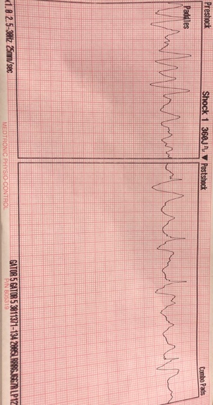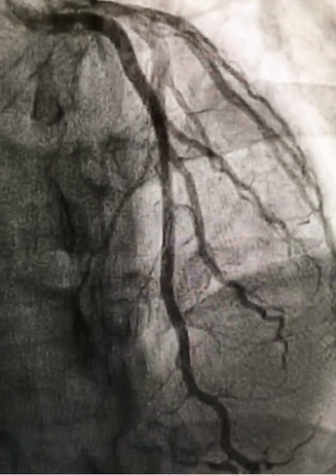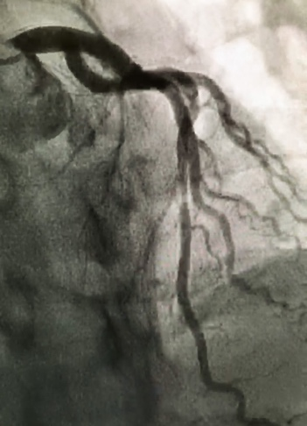
Figure 1: Initial rhythm strip from finish line AED) Figure 2: Mid LAD myocardial bridge during diastole(left) and systole (right)

